Phase 3
Metasploit Exploitation Report

Objective
The Goal of this Exercise was to perform Pentesting / Exploitation using Metasploit tool. The Target machine was Machine was Metasploitable 2. This report demonstrates enumeration, exploitation, post exploitation and Remote code execution.

Tools Used
- Kali Linux
- Metasploit
- Nmap insde Metasploit

Methodology
- Enumeration
Enumeration began by launching Metasploit and verifying the databases. Nmap Built-in Metasploit was used to scan the machine using the command “ db_nmap -sC -sV <target-ip> “.
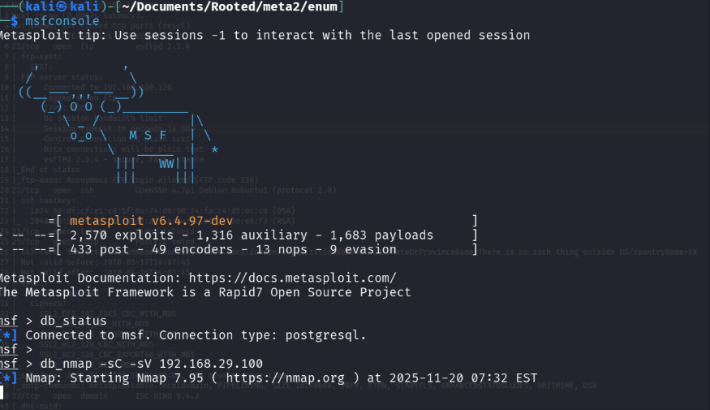
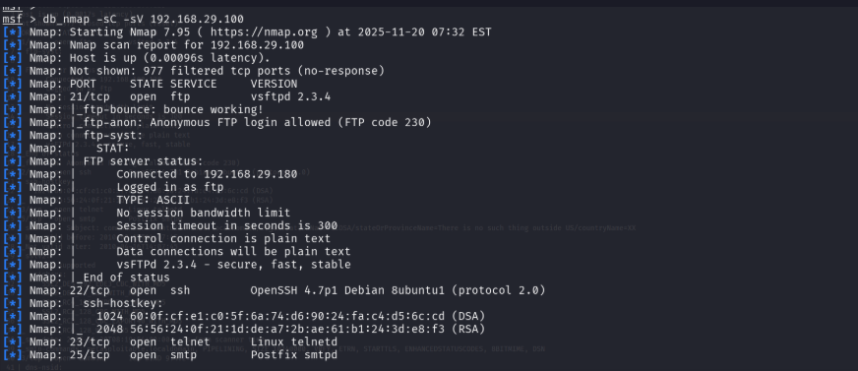

- Exploitation
Using the intel gathered from the enumeration phase we observed several services exposed and quite few of them were vulnerable. We choose to research about ftp service.

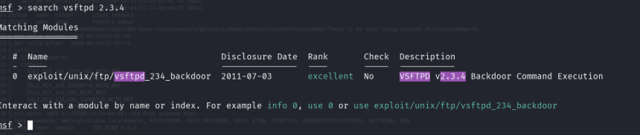

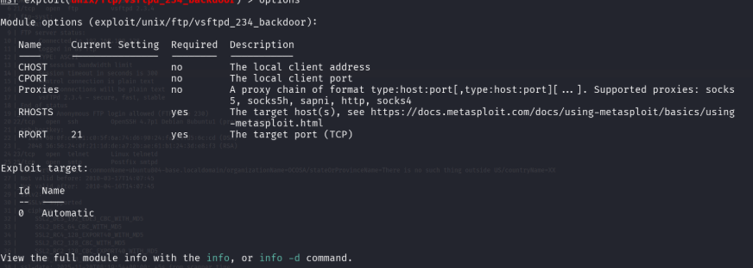

Exploit was configured where Rhosts was added (target VM IP). and payloads were selected.
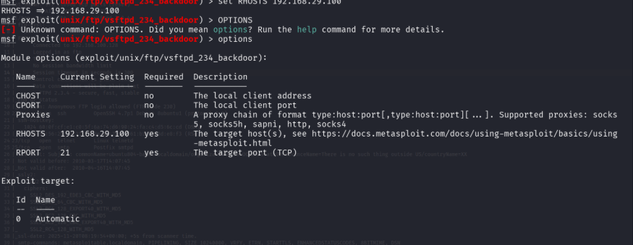

- Post Exploitation
Once Exploit was Configured, we exploited the exploit using the exploit command. It resulted in the interactive shell with the target machine and the session was running root privileges.
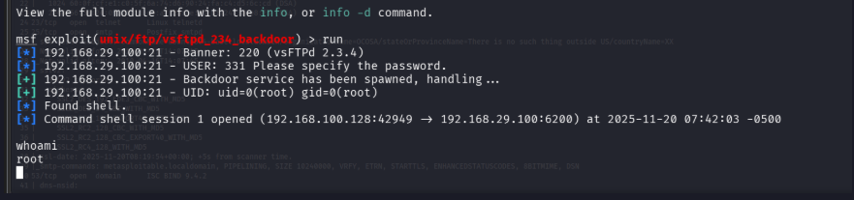

Exploit Simulation

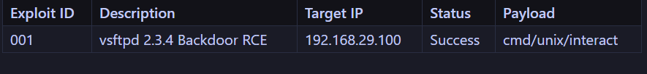

POC Validation
The PoC for vsftpd verifies that ftp service contains a backdoor triggered by user name containing the string :). Metasploit Replicates this this behavior and we were able to spawn the reverse tcp shell (interactive). This exercise of PoC confirms the existence of the Critical RCE Vulnerability.

